2. Create table given below: Employee and IncentiveTable

Table 1 : Employee
Create table employee(
Employee_id int primary key auto increment not null,
First_name varchar(20),
last_name varchar(20),
salary bigint , joining_date varchar(50) ,
department varchar(20)
);

insert into employee(First_name, last_name , salary,joining_date, department)VALUES
("johan", "Abrahan" , 10000000 ,"01-JAN-13 12.00.00 AM","banking" ),
("Mitchal", "clarke", 8000000 ,"01-JAN-13 12.00.00 AM","insurance" ),
("Roy", "Thomes", 7000000 ,"01-FEB-13 12.00.00 AM","banking" ),
("Tom" , "jose" ,6000000,"01-FEB-13 12.00.00 AM","insurance"),
("jerry" , "pinto" , 650000 ,"01-FEB-13 12.00.00 AM", "insurance"),
("Philip" , "Mathew" , 750000 ,"01-JAN-13 12.00.00 AM", "service"),
("test name 1" ," 123" , 650000 ,"01-JAN-13 12.00.00 AM", "service"),
("teat name 2", "lname % ", 600000 ,"01-FEB-13 12.00.00 AM", "insurance");

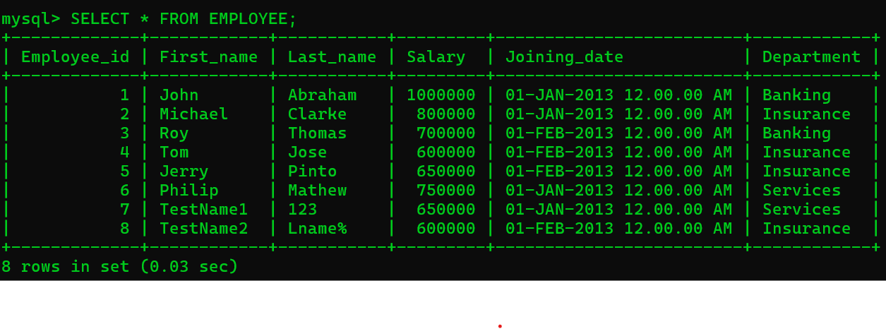

Table 2 : Incentive

CREATE TABLE Incentive(
Employee_ref_id INT NOT NULL, FOREIGN KEY(Employee_ref_id) REFERENCES Employee(Employee_id),
Incentive_date VARCHAR(50),
Incentive_amount INT
);
INSERT INTO Incentive VALUES(1, "01-FEB-13", 5000),
(2, "01-FEB-13", 3000),
(3, "01-FEB-13", 4000),
(1, "01-JAN-13", 4500),
(2, "01-JAN-13", 3500);
